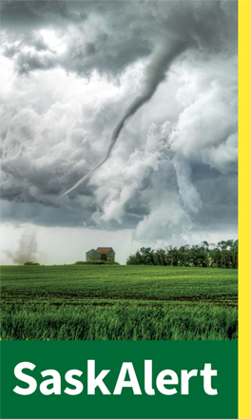
SaskAlert

SaskAlert is a public alerting program that provides critical information on emergencies in real time, so you can take action to protect yourself, your family and your property. An emergency alert issued through SaskAlert will let you know:

- What the emergency is
- Where it is happening
- Instructions for you to follow to stay safe, and
- Advise you when the incident is over
The RM and Town of LeRoy will soon be broadcasting alerts about local emergency events to the public.

Please check back for Emergency Alert numbers
which will be coming into effect soon.

_____________________________________________________________________________

SaskAlert
Mobile App Instructions

Please see the new SaskAlert mobile app instructions by clicking on the link below. Feel free to share these instructions with anyone you see fit.

Mobile App Instructions

